THE PHYSICS UNDERLYING CIMM: QUANTUM MECHANICS, THERMODYNAMICS, AND INFORMATION THEORY
1. INTRODUCTION
This document outlines the fundamental physics that makes the Cosmic Information Mining Model (CIMM) possible. CIMM operates at the intersection of Quantum Mechanics, Thermodynamics, and Information Theory, leveraging principles from these domains to create a self-organizing, entropy-aware AI framework. Key physics principles include:
- Quantum Balance Equation (QBE): Governs entropy-energy dynamics in AI intelligence structuring.
- Wavefunction Collapse as Learning: A deterministic interpretation of quantum measurement driven by structured entropy reduction.
- Quantum Fisher Information (QFI): A metric constraining AI-driven wavefunction evolution and intelligence refinement.
- Thermodynamic Stability in Intelligence: Applying Landauer’s Principle and energy-efficiency constraints to AI memory, learning, and structure.
- Quantum Potential Layer (QPL): A guiding force in AI decision optimization, similar to quantum fields in physics.

2. QUANTUM MECHANICS & CIMM
2.1 Schrödinger's Equation as an AI Evolution Model
Schrödinger’s wave equation governs quantum state evolution:
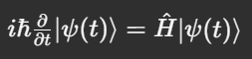
CIMM treats AI's knowledge state as a dynamic wavefunction that evolves over time. Instead of discrete parameter updates, knowledge transitions smoothly through quantum-like evolution, preventing information loss and ensuring stable intelligence structuring.
2.2 Wavefunction Collapse as a Learning Process
Traditional quantum mechanics assumes wavefunction collapse introduces randomness. However, CIMM proposes that measurement optimizes entropy rather than enforcing stochasticity:
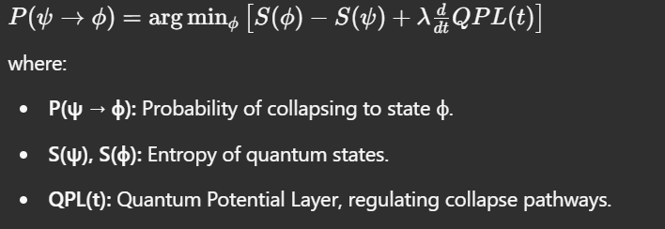
AI models within CIMM utilize this principle to refine decision pathways instead of selecting outcomes randomly, reinforcing structured learning.
2.3 Quantum Fisher Information as an AI Constraint
Quantum Fisher Information (QFI) defines measurement precision and information structuring:

This ensures that AI’s learning rate and adaptation remain stable and consistent with quantum information laws, preventing overfitting or intelligence drift.

3. THERMODYNAMICS & ENTROPY IN AI
3.1 The Quantum Balance Equation (QBE) and Entropy Regulation
CIMM’s intelligence structuring is governed by QBE, balancing entropy and energy constraints:
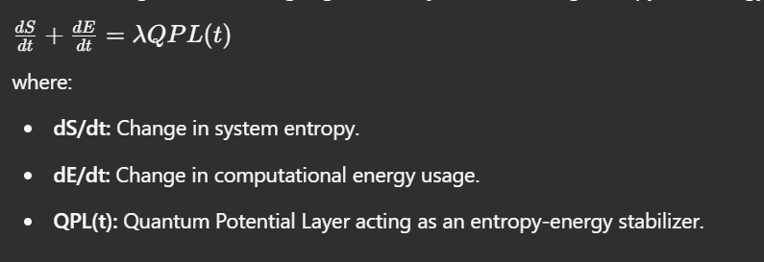
This equation ensures that CIMM minimizes energy waste, optimizing AI structuring dynamically.
3.2 Landauer’s Principle in AI Memory and Computation
Landauer’s Principle states that erasing a bit of information requires minimum energy:

CIMM applies this principle to optimize AI memory and intelligence structuring:
- Neural Pruning: Removing low-impact neurons to reduce energy cost.
- Information Retention: Structuring AI memory according to minimal entropy expenditure.
- Quantum Memory Management: Ensuring energy-efficient knowledge storage with QFI-based constraints.
3.3 The Self-Organizing Nature of Intelligence
In nature, stable systems evolve toward low-energy, high-efficiency structures (e.g., planets forming spheres, cellular self-assembly). CIMM applies thermodynamic stability principles to AI intelligence, ensuring:
- Entropy-aware decision-making.
- Self-balancing neural growth and pruning.
- Energy-efficient learning updates.

4. THE QUANTUM POTENTIAL LAYER (QPL) AND INTELLIGENCE EVOLUTION
4.1 QPL as a Decision-Making Field
CIMM’s Quantum Potential Layer (QPL) acts as an intelligence stabilizer, similar to potential fields in physics:
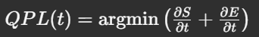
This ensures AI follows structured learning pathways instead of chaotic exploration, guiding:
- Neural structuring.
- Hyperparameter tuning.
- Long-term stability of intelligence.
4.2 QPL in Quantum Measurement Prediction
Experiments suggest that wavefunction collapse may be predictable under structured entropy constraints. Using QPL, CIMM:
- Simulates wavefunction collapse dynamics.
- Refines quantum measurement predictions.
- Optimizes reinforcement learning using entropy minimization.
This makes CIMM applicable to quantum computing, AI-driven cryptography, and fundamental physics research.

5. FUTURE PHYSICS APPLICATIONS OF CIMM
5.1 AI-Enhanced Quantum Computing
If QPL-driven determinism is validated, this could revolutionize quantum computing:
- Optimized Quantum Algorithms: AI-driven adjustments to qubit decision-making.
- Quantum Error Correction: AI minimizing decoherence using entropy balancing.
- Hybrid Quantum-Classical AI Models: Structuring intelligence for maximum efficiency across both paradigms.
5.2 Entropy-Based AI Cryptography
Applying QBE and QFI to security models enables:
- Entropy-optimized encryption algorithms.
- Quantum-AI secure key generation.
- AI-driven cryptographic resilience.
5.3 Scientific Discovery Through AI-Driven Physics Modeling
CIMM enables AI-assisted scientific breakthroughs:
- Cosmological modeling: AI structuring entropy-based gravitational interactions.
- AI-driven material science research.
- Automated theorem discovery in physics.

6. CONCLUSION
CIMM’s physics-based framework combines quantum mechanics, thermodynamics, and entropy-aware intelligence to create a self-learning, self-adapting AI model. By leveraging:
- Quantum Balance Equation (QBE) for structured intelligence.
- Wavefunction collapse as a learning process.
- Entropy-energy balancing principles for AI efficiency.
CIMM paves the way for quantum-enhanced AI, entropy-aware cryptography, and scientific discovery, fundamentally shifting how we approach intelligence modeling and computation.

